
Sitting
1
Session 18
DAILY FACTSHEET


Assembly
Min
Hours
2
08
Punjab Assembly
Punjab PA Extends Five Ordinances
ISLAMABAD, November 12, 2015: The Punjab Assembly passed five resolutions to extend as many ordinances for a further period of ninety days during first sitting of its 18th session, says Free and Fair Election Network (FAFEN) on Thursday.
Following are some key observations of the House proceeding:
Members' Participation in House Proceedings
- The Punjab Assembly met for 2 hours and 8 minutes.
Key Members Attendance
Speaker | Present
Deputy Speaker | Absent
Chief Minister | Absent
Leader of the Opposition | Present

- The sitting started at 1643 hours against the scheduled time 1400 hours.
- The Speaker presided over the entire sitting while the Deputy Speaker was absent.
- The Chief Minister did not attend the sitting.
- The Leader of the Opposition attended the sitting for an hour and eight minutes.
- 56 MPAs (15%) were present at outset and 40 (10%) at adjournment of the sitting.
- Only the parliamentary leader of JI was present.
- Five minority members were present.
Punjab Assembly swears in two new lawmakers Jahangir Khanzada (PP-16) and Shoaib Siddiqui (PP-147).

Provincial Law Minister laid two Ordinances before the House and introduced a Government Bill.

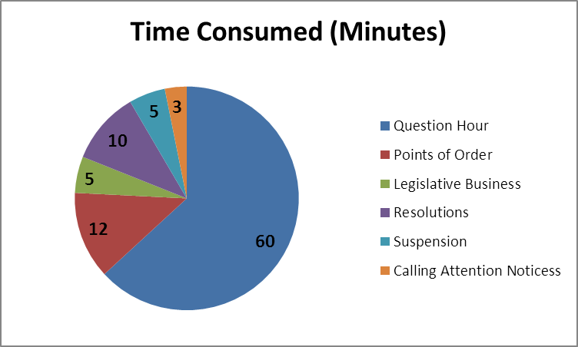
Output
- The Provincial Law Minister laid before the Punjab Revenue Authority (Amendment) Ordinance 2015 and the Punjab Sugar Factories Control (Amendment) Ordinance 2015 before the House.
- The Provincial Law Minister also introduced the Canal and Drainage (Amendment) Bill 2015.
- Also moved by Provincial Law Minister, the House passed five resolutions to extending as many Ordinances for a further period of 90 days. These Ordinances included the Punjab Pure Food (Amendment) Ordinance 2015, the Infrastructure Development Authority of the Punjab Ordinance 2015, the Punjab Private Educational Institutions (Promotion and Regulation) (Amendment) Ordinance 2015, the Ghazi University, Dera Ghazi Khan (Second Amendment) Ordinance 2015 and the Ali Institute of Education Lahore (Amendment) Ordinance 2015.

Representation and Responsiveness
- The House took up three Calling Attention Notices (CANs), two of which were responded to by the Provincial Law Minister while one was disposed of due to suspension of mover’s membership.
- The House took up 27 out of 35 starred questions, 12 of which were responded to by relevant ministry (Health Ministry), five were pended and 10 were disposed of. The lawmakers asked 25 supplementary questions as well.

Order and Institutionalization
- Four lawmakers spoke on six points of order consuming 12 minutes of the proceeding.
- A PTI lawmaker pointed out the lacking quorum at 1817 hours leading to the suspension of proceeding for five minutes.
- PTI lawmakers protested on floor of the House for one minute for not allowing Leader of the Opposition to speak on a Point of Order. Following the protest, the lawmakers walked out from the House at 1835 hours and did not return for rest of the sitting’s time.

Transparency
- ‘Orders of the Day’ was available to the legislators, observers and public.
- The attendance of lawmakers was available to the media and observers.

The daily factsheet is based on direct observation of the Punjab Assembly proceedings conducted by PATTAN Development Organization – a member organization of FAFEN. Errors and omissions are regretted.

