
Sitting
2
Session 25
DAILY FACTSHEET


Assembly
Min
Hours
6
15
National Assembly
NA Elects Speaker,
Passes One Bill
ISLAMABAD, November 9, 2015: The National Assembly swore in the newly elected Speaker Sardar Ayaz Sadiq on Monday during second sitting of its 25th session, says Free and Fair Election Network (FAFEN).
The Acting Speaker administered oath to Ayaz Sadiq who won election of the Speaker by securing 268 votes against PTI candidate Shafqat Mahmood who got 31 votes while one vote was rejected.
The House did not take up a bill, a motion of thanks, a motion under rule 259 and a CAN appearing on the agenda.
Following are some key observations of the House proceeding:
Key Members Attendance
Speaker | Present
Deputy Speaker | Present
Prime Minister | Present
Leader of the Opposition | Present

Members' Participation in House Proceedings
- The National Assembly met for 6 hours and 15 minutes.
- The sitting started at its scheduled time 09:00am and ended at 03:15pm.
- The Acting Speaker presided over the sitting for four hours and 40 minutes while the Speaker chaired the proceeding for remaining an hour and 35 minutes.
- The Prime Minister attended the sitting for twenty minutes.
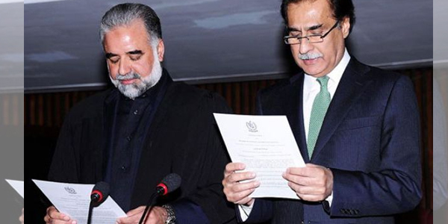
- The Leader of the Opposition attended the sitting for four hours and 20 minutes.
- 32 MNAs (9%) were present at outset and 18 (5%) at end of the sitting.
- The parliamentary leaders of PTI, MQM, JUI-F, JI, PkMAP, NPP, ANP and sole members of APML, QWP-S, BNP, NP, AJIP, PML-Z and AML were present.
- All ten minority members were present.
Output
- The National Assembly passes a bill and a resolution while another bill, two motions and a CAN appearing on the agenda were not taken up.
- Two ordinances and a report were presented before the House.

- The Parliamentary Secretary for Interior & Narcotics Control laid before the House two ordinances namely the Foreigners (Amendment) Ordinance, 2015 and the National Database and Registration Authority (Amendment), 2015.
- Moved by Parliamentary Secretary for Finance, the House also approved a resolution to extend the Income Tax (Amendment) Ordinance, 2015 for a further period of 120 days with effect from November 7, 2015.
- Also moved by Parliamentary Secretary for Finance, the House passed the State Bank the State Bank of Pakistan (Amendment) Bill, 2015.
- On behalf of Minister for Law, Justice& Human Rights, the Federal Minister for Kashmir Affairs & Gilgit Baltistan presented the Annual Report of the National Commission on Status of Women for year 2013.

Order and Institutionalization
- Fourteen lawmakers spoke on as many points of order consuming 80 minutes of the proceeding. The members used these points of order to congratulate the Speaker on his successful election.

Transparency
- ‘Orders of the Day’ was available to the legislators, observers and public.
- The attendance of lawmakers was available to the media and observers.

This daily factsheet is based on direct observation of the National Assembly proceeding conducted by Free and Fair Election Network (FAFEN). Errors and omissions are excepted

