
Sitting
3
Session 25
DAILY FACTSHEET


Assembly
Min
Hours
4
25
National Assembly
NA Leaves Entire Agenda Unaddressed Except CANs
ISLAMABAD, November 10, 2015: The National Assembly left its entire agenda unaddressed except two Calling Attention Notices (CANs) on Tuesday during third sitting of its ongoing 25th session, says Free and Fair Election Network (FAFEN).
There were 47 items on agenda of Private Members’ Day of which 45 remained unaddressed. State Minister for Parliamentary Affairs responded to two CANs while rest of the time was consumed in Points of Order.
Following are some key observations of the House proceeding:
Key Members Attendance
Speaker | Absent
Deputy Speaker | Present
Prime Minister | Absent
Leader of the Opposition | Present

Members' Participation in House Proceeding
- The National Assembly met for 4 hours and 25 minutes
- The sitting started at 1055 hours against the scheduled time of 1030 hours
- The House took a prayer break for 36 minutes
- The Deputy Speaker presided over the entire sitting as the Speaker was absent
- The Prime Minister did not attend the sitting
- The Leader of the Opposition attended the sitting for fifty minutes
- 54 MNAs (16%) were present at outset and 3 (1%) at adjournment of the sitting
- The parliamentary leaders of JI, PkMAP, ANP and sole members of APML, QWP-S, PML-Z and AML were present
- National Assembly spent three hours on Points of Order (POs) and did not take up ten bills, five reports, four motions, two resolutions and an amendment to rules of procedure.
- Six minority members were present
- 28 members applied for leave
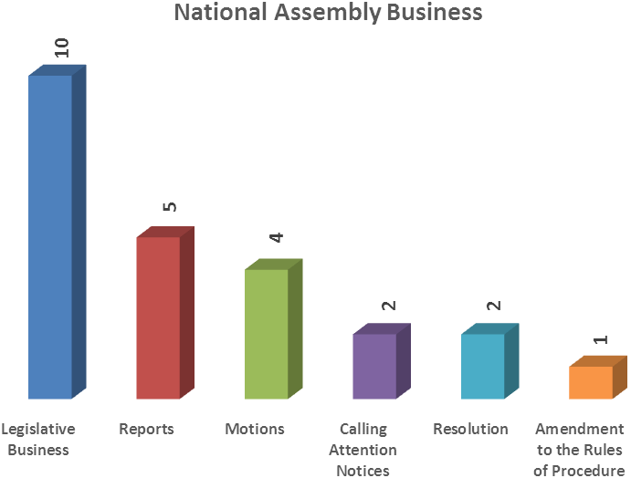

Representation and Responsiveness
- State Minister for Parliamentary Affairs responded to two CANs regarding cancellation of cabin allotments by CDA and improper functioning of sewerage treatment plant.
Order and Institutionalization
- Lawmakers spoke on 37 points of order consuming three hours of the proceeding. The members used these points of order to express their views on recent earthquake and relief efforts.
- PML-F lawmakers staged a walkout at 1115 hours over killings in Khairpur during first phase of LG polls. They did not return to the House for the rest of the sitting.
- PPPP and JI lawmakers staged a walk-out for five minutes against indifferent attitude of federal government towards victims of bomb blast in a Muhrram procession in Jacobabad.
- A PML-N lawmaker from FATA walked out of the House at 1317 hours against the behavior of Governor Khyber Pakhtunkhwa whom he accused of barring him from talking to President and Prime Minister during their visits to quake-hit areas. He did not return to the House.

Transparency
- ‘Orders of the Day’ was available to the legislators, observers and public.
- The attendance of lawmakers was available to the media and observers.

This daily factsheet is based on direct observation of the National Assembly proceeding conducted by Free and Fair Election Network (FAFEN). Errors and omissions are excepted

