
Sitting
3
Session 26
DAILY FACTSHEET

National Assembly

42% Agenda Left Unaddressed due to Movers’ Absence
Assembly
Min
Hours
2
20
ISLAMABAD, November 24, 2015: The National Assembly left 42 percent agenda unaddressed due to absence of movers on Tuesday during first Private Members’ day of 26th session, says Free and Fair Election Network (FAFEN) in its Daily Factsheet.
Following are some key observations of the House proceeding:
Members' Participation in House Proceeding
- The National Assembly met for two hours and twenty minutes
- The sitting started at 1035 hours against the scheduled time of 1030 hours
- The Speaker presided over the sitting for 110 minutes while the Deputy Speaker chaired rest of the proceeding
Key Members Attendance
Speaker | Present
Deputy Speaker | Present
Prime Minister | Absent
Leader of the Opposition | Present

- The Prime Minister did not attend the sitting
- The Leader of the Opposition attended the sitting for 17 minutes
- 27 MNAs (8%) were present at outset and 31 (9%) at adjournment of the sitting
- The parliamentary leaders of PkMAP, JI, AMLP, and QWP-S were present
- Three minority members were present

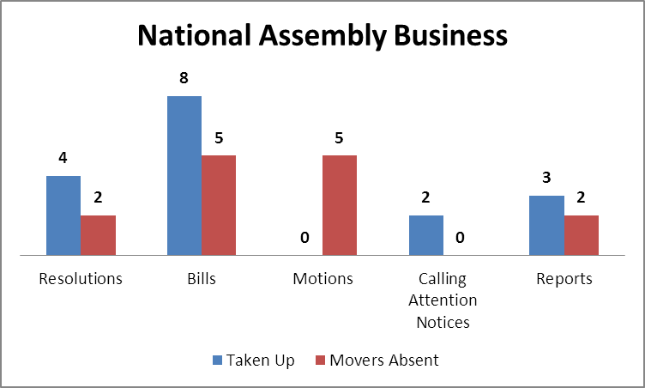

Output
- Eight bills were introduced in the House and sent to relevant committees. The lawmakers belonging to PTI and JI sponsored three bills each while two bills were moved by the JUI-F lawmakers. These bills included the Eradication of Riba Bill, 2015, two different bills by the name of the Code of Civil Procedure Amendment Bill, 2015, three Constitutional Amendment Bills, the Anti-Terrorism Amendment Bill, 2015 and the Pakistan Bait-ul-Mal Amendment Bill, 2015. Two Constitutional Amendment Bills were clubbed together for being identical. These two were brought separately by female MNAs and male MNAs belonging to JUI-F.
- Chairman Standing Committee on Rules of Procedure and Privileges presented before the House three reports of the committee on as many Questions of Privilege. The reports were laid after passage of motions to condone the delay in their presentation.
- The House adopted four resolutions urging government to build more water reservoirs (moved by MQM lawmaker), establish a women university in Buner (moved by JI lawmaker), implement the package for deceased employees (moved by female lawmaker of PML-N) and take action against sale of counterfiet drugs in Federal Capital (moved by female lawmaker of PPPP).
Representation and Responsiveness
- The House took up two Calling Attention Notices regarding gas supply to textile industry in Faisalabad and losing the vote to get membership of Human Rights Council in Geneva.
Order and Institutionalization
- Thirteen lawmakers spoke on matters other than Points of Order under Rule 18. The members paid tribute to the political services of late Makhdom Amin Fahim and also condemened death sentences to political leaders in Bangladesh.
Transparency
- ‘Orders of the Day’ was available to the legislators, observers and public.
- The attendance of lawmakers was available to the media and observers.

This daily factsheet is based on direct observation of the National Assembly proceeding conducted by Free and Fair Election Network (FAFEN). Errors and omissions are excepted

