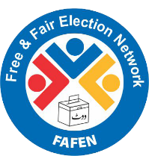
Sitting
4
Session 25
DAILY FACTSHEET


Assembly
Min
Hours
3
26
National Assembly
NA Passes Two Bills
ISLAMABAD, November 11, 2015: The National Assembly passed two government bills on Wednesday during the fourth and last sitting of its 25th session, says Free and Fair Election Network (FAFEN).
The session was prorogued sine die earlier than scheduled due to upcoming second phase of local government elections in Sindh and Punjab. The House also passed a motion seeking to carry forward the remaining resolutions, questions and CANs of this session to the next session.
Following are some key observations of the House proceeding:
Members' Participation in House Proceeding
- The National Assembly met for three hours and 26 minutes
Key Members Attendance
Speaker | Present
Deputy Speaker | Present
Prime Minister | Absent
Leader of the Opposition | Present

- The sitting started at 1035 hours against the scheduled time of 1030 hours
- The proceeding House was suspended for 29 minutes
- The Speaker presided over the sitting for an hour and 12 minutes while the Deputy Speaker chaired the rest of the sitting
- The Prime Minister did not attend the sitting
- The Leader of the Opposition attended the sitting for an hour and 10 minutes
- 32 MNAs (9%) were present at outset and 13 (3%) at adjournment of the sitting
- The parliamentary leaders of JI, PkMAP, ANP and sole members of APML, QWP-S, and AML were present
- Five minority members were present
- 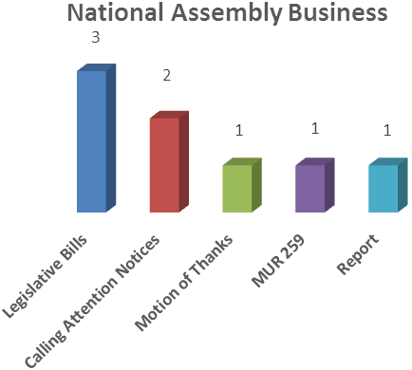
- 15 members applied for leave
Output
- The State Minister for National Health Services, Regulation and Coordination laid before the House the Pakistan Medical and Dental Council (Amendment) Ordinance, 2015.
- The Parliamentary Secretary for Finance presented report on 1st Biannual Monitoring on the implementation of 7th National Finance Commission (NFC) Award (July-December, 2014).
- Introduced by Parliamentary Secretary for Defence, the House passed the Pakistan Army (Amendment) Bill, 2015 with majority vote. Nine lawmakers spoke on it for 25 minutes
- Another bill – the Minimum Wages for Unskilled Workers (Amendment) Bill, 2015 – introduced by Parliamentary Secretary for Inter-Provincial Coordination was unanimously passed by the House. Eight lawmakers spoke for eight minutes on it .

Representation and Responsiveness
- On proposal of a PPPP lawmaker, the Chair disposed of a motion under rule 259 regarding recent heatwave in the country especially in Sindh.
- The House took up five out of 42 starred questions appearing on the agenda while the members asked six supplementary questions.
- The House took up two CANs regarding increase in fee of private educational institutions and discontinuation of Wasila-e-Haq program. The relevant parliamentary secretaries responded to these CANs.
Order and Institutionalization
- Lawmakers spoke on 27 Points of Order consuming 62 minutes.
- The proceeding of the House remained suspended for 29 minutes due to absence of secretaries of the relevant ministries during the Question Hour.
- The House also adopted a supplementary motion moved by a female lawmaker of PPPP to carry forward the pending questions, resolutions and CANs of this session to the next session.
- A male lawmaker hailing from PkMAP staged a token walkout against absence of ministers from the House.

Transparency
- ‘Orders of the Day’ was available to the legislators, observers and public.
- The attendance of lawmakers was available to the media and observers.

This daily factsheet is based on direct observation of the National Assembly proceeding conducted by Free and Fair Election Network (FAFEN). Errors and omissions are excepted

