
Sitting
1
Session 27
DAILY FACTSHEET

National Assembly

NA Takes Up Half of its Agenda
Assembly
Min
Hours
3
55
ISLAMABAD, December 7, 2015: The National Assembly addressed almost half of its agenda appearing on ‘Orders of Day’ on Monday during first sitting of its 27th session, says Free and Fair Election Network (FAFEN) in its Daily Factsheet.
Following are some key observations of the House proceeding:
Members' Participation in House Proceeding
- The National Assembly met for three hours and 55 minutes while
also took 20 minutes long prayer-break
- The sitting started at 1610 hours against the scheduled time of 1600 hours
- The Speaker presided over the entire sitting
Key Members Attendance
Speaker | Present
Deputy Speaker | Present
Prime Minister | Absent
Leader of the Opposition | Present

- The Prime Minister did not attend the sitting
- The Leader of the Opposition attended the sitting for an hour and 53 minutes
- 28 MNAs (8%) were present at outset and 32 (9%) at adjournment of the sitting
- The parliamentary leaders of PkMAP, JI, ANP, AMLP, APML, JUI-F, PML-Z, PML-F and QWP-S were present
- Seven minority members were present
- 12 members applied for leave

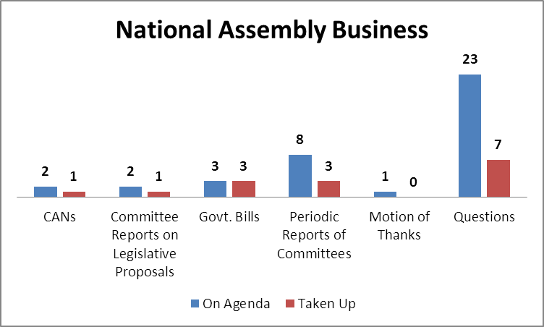
Points of Order consumed more than half of the total duration of this sitting.

Output
- The National Assembly passed with majority vote the Pakistan Halal Authority Bill, 2015, the Publication of Laws of Pakistan Bill, 2015 and the Patents (Amendment) Bill, 2015.
- Chairman Standing Committee on Law & Justice presented the report of the Standing Committee on the Criminal Law (Amendment) Bill, 2015.
- Chairmen of Standing Committees on National Food Security & Research and Law Justice & Human Rights presented the periodic reports of their committees as well.
- On behalf of Chairman of the Standing Committee on House and Library, the Minister of State for Parliamentary Affairs presented the periodic report of the committee.
Representation and Responsiveness
- The House took up seven of 23 starred questions appearing on the agenda. Members asked 13 supplementary questions as well.
- The Minister of State for National Health Services, Regulations and Coordination responded to a Calling Attention Notice regarding non-availability of any Drugs testing authority in the country.
Order and Institutionalization
- Lawmakers spoke on 17 Points of Order consuming two hours and four minutes of the proceedings.
- The Opposition parties staged a walk-out at 1805 hours against privatization of Pakistan International Airlines.

Transparency
- ‘Orders of the Day’ was available to the legislators, observers and public.
- The attendance of lawmakers was available to the media and observers.

This daily factsheet is based on direct observation of the National Assembly proceeding conducted by Free and Fair Election Network (FAFEN). Errors and omissions are excepted

