
Sitting
7
Session 27
DAILY FACTSHEET

National Assembly

NA Leaves Most of its Agenda Unaddressed
Assembly
Min
Hours
2
29
ISLAMABAD, December 15, 2015: The National Assembly left major part of its agenda appearing on ‘Orders of the Day’ unaddressed partly due to absence of movers on Tuesday during seventh sitting of ongoing 27th session, says Free and Fair Election Network (FAFEN) in its Daily Factsheet.
Following are some key observations of the House proceeding:
Members' Participation in House Proceeding
- The National Assembly met for two hours and 29 minutes
- The sitting started at 1046 hours against the scheduled time of 1030 hours
- The Speaker chaired the sitting for an hour and 19 minutes while the Deputy Speaker presided over the rest of the proceeding
Key Members Attendance
Speaker | Present
Deputy Speaker | Present
Prime Minister | Absent
Leader of the Opposition | Present

- The Prime Minister did not attend the sitting
- Six Federal Ministers attended the sitting
- The Leader of the Opposition attended the sitting for 66 minutes
- 33 MNAs (10%) were present at outset and 47 (14%) at adjournment of the sitting
- The parliamentary leaders of APML, ANP, PML-Z and JI were present
- Ten minority members were present

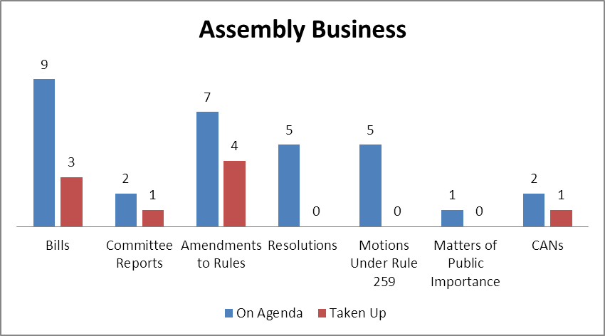
Output
- The House rejected the Islamabad Capital Territory Food Authority Bill, 2015 moved by a PTI female lawmaker.
- The House referred the Fair Representation of Women Bill, 2015 and the National Commission for Minority Rights Bill, 2015 to relevant standing committees. These bills were also moved by PTI lawmakers.
- Chairman Standing Committee on Law & Justice presented the report of the committee on the Law Reforms (Amendment) Bill, 2015. The House condoned the delay in presentation of the report.
- Moved by two PML-N male legislators, the House adopted a motion to amend the Rules 48, 69 and 112 of the Rules of Procedure.
- The House referred to the relevant standing committees three motions to amend the Rules 118 and 120 (2) of the Rules of Procedure. Two of these amendments were moved by PTI lawmakers and one by JUI-F members.
Representation and Responsiveness
- The House took up a Calling Attention Notice (CAN) regarding non-payment of Rs. 4,00,000/- to those tribesmen each whose houses were destroyed and Rs. 1,60,000/- to those whose houses were damaged during the military operation in FATA. The Federal Minister for States and Frontier Regions responded to the notice.
Order and Institutionalization
- Members spoke on 13 Points of Order consuming 23 minutes of the proceeding.
Transparency
- ‘Orders of the Day’ was available to the legislators, observers and public.
- The attendance of lawmakers was available to the media and observers.

This daily factsheet is based on direct observation of the National Assembly proceeding conducted by Free and Fair Election Network (FAFEN). Errors and omissions are excepted

