
Sitting
9
Session 27
DAILY FACTSHEET

National Assembly
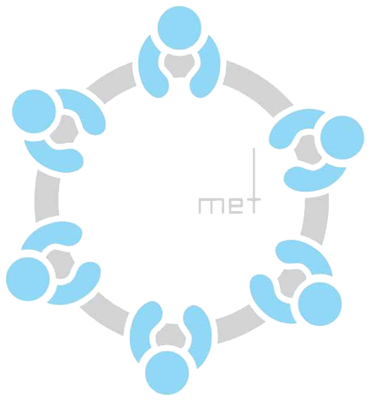
NA Takes Up Two Thirds of its Agenda
Assembly
Min
Hours
5
10
ISLAMABAD, December 17, 2015: The National Assembly transacted two thirds of its business appearing on ‘Orders of the Day’ on Thursday during ninth sitting of ongoing 27th session, says Free and Fair Election Network (FAFEN) in its Daily Factsheet.
Following are some key observations of the House proceeding:
Members' Participation in House Proceeding
- The National Assembly met for five hours and 10 minutes
- The sitting started at 1035 hours against the scheduled time of 1030 hours
- The Speaker chaired the entire sitting
Key Members Attendance
Speaker | Present
Deputy Speaker | Absent
Prime Minister | Absent
Leader of the Opposition | Absent

- The Prime Minister did not attend the sitting
- Eleven Federal Ministers attended the sitting
- The Leader of the Opposition did not attend the sitting
- 42 MNAs (12%) were present at outset and 29 (8%) at adjournment of the sitting
- The parliamentary leaders of APML, AMLP, JI, QWP-S and PML were present
- Six minority members were present
- Thirty three members applied for leave
Representation and Responsiveness
- The House took up 12 out of 30 starred questions appearing on the agenda. Members also asked 22 supplementary questions.
- The treasury responded to two Calling Attention Notices (CANs) regarding weak state of economy in the country and discrimination against FATA in payment of compensation to heirs of people martyred in incidents of terrorism.
- Eight lawmakers discussed a Motion under Rule 259 regarding the performance of Ministry of Interior & Narcotics Control for three hours and 12 minutes.
- The House approved a motion seeking to constitute a Parliamentary Committee on Privatization of Pakistan International Airlines (PIA).
Order and Institutionalization
- Members spoke on four Points of Order consuming three minutes of the proceeding.
Transparency
- ‘Orders of the Day’ was available to the legislators, observers and public.
- The attendance of lawmakers was available to the media and observers.

This daily factsheet is based on direct observation of the National Assembly proceeding conducted by Free and Fair Election Network (FAFEN). Errors and omissions are excepted

